1: Button component in Newzera website

Brief idea of the project

Developed the Button components(Circular Buttons, Activity Buttons and Rectangular Buttons) for the newzera website and tested them if they are being rendered correctly to the display screen.

Project status

Pull request merged successfully. Refer to the “Deliverables” section in the design doc in order to locate the codes/assets of this project.

Design document

Link to the design document - [Button components](https://docs.google.com/document/d/1mHPv7tw6qMlPJ05LayYJ838SbFlnFE92Hhs_sGYVzf8/edit)

Supporting documents

No additional documents were created in this project

Observations

1. Whole project can be divided into 3 components(Circular Buttons, Activity Buttons and Rectangular Buttons).
2. The status of button i.e. disabled, filled (coloured), bordered (only border and text is coloured) or default can be changed by providing appropriate props.
3. Type of Activity button i.e. share, raven or react can be accessed with the help of activityType prop.
4. The rectangular buttons’ width, height, text, font size and border-radius can be passed in as props.

Challenges

1. Was not able to implement onClick/onPress/onToggle function for buttons.Hence just implemented a pointer when a cursor is hovered over a button.
2. Converting the height and width of buttons from pixels to vw/vh in order to make the page responsive. It was very time consuming.
3. To come up with the idea of having only one component for all the rectangular button types. Took some time to understand what props should be considered for this component.

Guidelines

1. To render **Circular Buttons**, follow below mentioned steps -

* Import CircleEllipse from obi/web/newzera-web/src/Components/Buttons/circleEllipse.js
* Use the CircleEllipse tag wherever you want the Circular button to be displayed.
* The boolean props associated with the CircleEllipse tag are “disabled” and “filled”. If neither of the props are passed, then the “default” circular button will be displayed.
* Default circular button         Filled circular button       Disabled  circular button

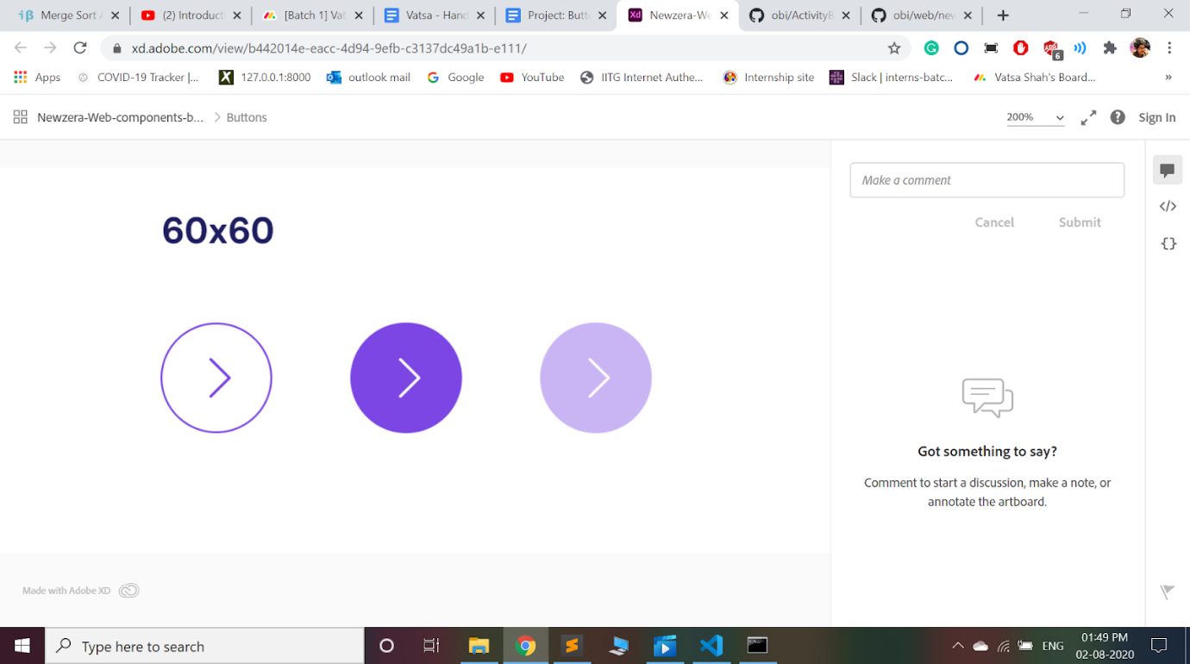

1. To render **Activity Buttons**, follow below mentioned steps -

* Import ActionBubble from obi/web/newzera-web/src/Components/Buttons/actionBubble.js
* Use the ActionBubble tag wherever you want the Activity button to be displayed.
* The prop (of type string) associated with the ActionBubble tag is “activityType”. activityType can have value of either “Share”, “Raven” or “React”. The default value is “Share”.
* Share Button      Raven Button     React Button

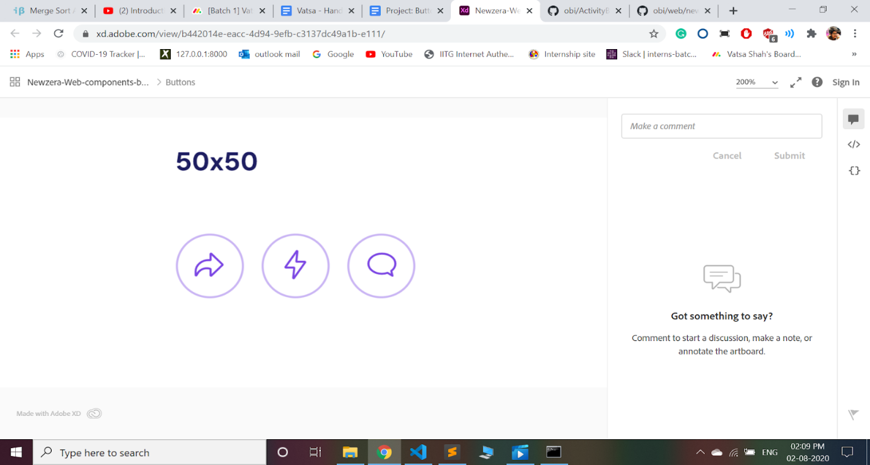

1. To render **Rectangular Buttons**, follow below mentioned steps -

* Import RectangleButton from obi/web/newzera-web/src/Components/Buttons/defaultButton.js
* Use the RectangleButton tag wherever you want the Rectangular Button to be displayed.
* The props associated with the RectangleButton tag are “height”, “width”, “radius”, “fontSize”, “disabled”, “bordered”, “filled” and “title”. The default prop values of the rectangular button are set to be width = 300px, height = 50px, radius = 0, fontSize = 18px, title = “Button”, and default = {true}. Prop values should be changed as per the requirements.

Known bugs

1. All the buttons have border thickness of 1px. Had issues in passing border width to CSS file.

Key points

1. The Button components developed in this project can be exported to any other component or display screen within obi/web/newzera-web/src.
2. To use a particular button in any flow page, the person will just need to import a particular button component he/she wants to use along with passing the props he/she wants to change.

Suggested next steps

The button components created in this project can be exported to other components requiring these type of buttons.

---------------------------------------------------------------------------------------------------------------------------

2: Entity component in Newzera website

Brief idea of the project

Developed the Entities component(Entity Card, Similar entity card, thumbnails, Entity in activity feed and list of entities) for the newzera website and tested them if they are being rendered correctly to the display screen.

Project status

Pull request merged successfully. Refer to the “Deliverables” section in the design doc in order to locate the codes/assets of this project.

Design document

Link to the design document - [Entity Component design doc](https://docs.google.com/document/d/1vGWBdEpXi7wT9gssD4W3mVh1Kl7mrU4Etxxn7l_SJjw/edit)

Supporting documents

No additional documents were created in this project

Observations

1. Whole project can be divided into 5 components(Entity Card, Similar entity card, thumbnails, Entity in activity feed and list of entities).
2. The varying inputs that go inside each component can be passed in as props.
3. The position of each component can also be fixed by passing two separate props. One to handle vertical position and other to handle horizontal position.

Challenges

1. The carousel for similar entities component.
2. Implementing maps instead of for loop in “Similar entities”, “Thumbnails”, “Entity in activity feed” and “List of entities” components.
3. Creating arrays of cards. It was time consuming and also difficult to implement.
4. Converting the height and width of components from pixels to vw/vh in order to make the page responsive. It was very time consuming.

Guidelines

1. To render **Entity Card**, follow below mentioned steps -

* Import EntityCard from obi/web/newzera-web/src/Components/Entity/entityCard.js
* Use the EntityCard tag wherever you want the Entity Card to be displayed.
* The props associated with the EntityCard tag are -

  entityName: string,

  entityDescription: string,

  entityImg: string,

  entityNumFollowing: number,

  entityIsFollowing: boolean,

  entityDetail: string,

  leftStartPoint: number,

  topStartPoint: number

* The default props for Entity Card are as follows -

  entityName: 'Donald Trump',

  entityDescription: 'President of the USA',

  entityImg: Images.Trump,

  entityNumFollowing: 54000,

  entityIsFollowing: false,

  entityDetail:

    'Lorem ipsum dolor sit amet, consectetur adipiscing elit,    sed do eiusmod tempor incididunt ut labore et dolore magna aliqua. Ut enim ad minim veniam.',

  leftStartPoint: 0,

  topStartPoint: 0

* The new prop values that need to be changed can be passed along with the EntityCard tag.

1. To render **Similar Entity Cards**, follow below mentioned steps -

* Import SimilarEntityCard from obi/web/newzera-web/src/Components/Entity/similarEntityCard.js
* Use the SimilarEntityCard tag wherever you want the Similar Entity Cards to be displayed.
* The props associated with the Similar Entity Card tag are -

  entityName: Array<string>,

  entityImg: Array<string>,

  entityIsFollowing: Array<boolean>,

  leftStartPoint: number,

  topStartPoint: number

* The default props for Similar Entity Card are as follows -

  entityName: [

    'India',

    'United States of America',

    'India',

    'United States of America',

    'India',

    'Trump',

    'India',

    'United States of America',

    'India',

    'United States of America',

    'India',

    'Trump'

  ],

  entityImg: [

    Images.India,

    Images.USA,

    Images.India,

    Images.USA,

    Images.India,

    Images.Trump,

    Images.India,

    Images.USA,

    Images.India,

    Images.USA,

    Images.India,

    Images.Trump

  ],

  entityIsFollowing: [false, false, true, true, true, false,     false, false, true, true, true, false],

  leftStartPoint: 0,

  topStartPoint: 0

* The new prop values that need to be changed can be passed along with the SimilarEntityCard tag.

1. To render **Thumbnails**, follow below mentioned steps -

* Import Thumb from obi/web/newzera-web/src/Components/Entity/thumb.js
* Use the Thumb tag wherever you want the Thumbnails to be displayed.
* The props associated with the Thumb tag are -

  entityThumbImg: Array<string>,

  leftStartPoint: number,

  topStartPoint: number

* The default props for Thumbs are as follows -

  entityThumbImg: [Images.Thumb1, Images.Thumb2, Images.Thumb3, Images.Thumb4],

  leftStartPoint: 0,

  topStartPoint: 0

* The new prop values that need to be changed can be passed along with the Thumb tag.

1. To render **Entities in Activity Feed**, follow below mentioned steps -

* Import EntitiesInActivityFeed from obi/web/newzera-web/src/Components/Entity/entitiesInActivityFeed.js
* Use the EntitiesInActivityFeed tag wherever you want the Entities In Activity Feed to be displayed.
* The props associated with the EntitiesInActivityFeed tag are -

  userName: string,

  userProfileImage: string,

  time: string,

  followingEntityImages: Array<string>,

  followingEntityNames: Array<string>,

  leftStartPoint: number,

  topStartPoint: number

* The default props for EntitiesInActivityFeed tag are as follows -

  userName: 'Amanda Will ',

  userProfileImage: Images.User,

  time: '4:45 pm',

  followingEntityNames: [

    'India',

    'ONU',

    'Donald Trump',

    'Donald Trump',

    'Donald Trump',

    'Donald Trump'

  ],

  followingEntityImages: [

    Images.Trump,

    Images.Trump,

    Images.Trump,

    Images.Trump,

    Images.Trump,

    Images.Trump

  ],

  leftStartPoint: 0,

  topStartPoint: 0

* The new prop values that need to be changed can be passed along with the EntitiesInActivityFeed tag.

1. To render **List Of Entities**, follow below mentioned steps -

* Import EntityList from obi/web/newzera-web/src/Components/Entity/listOfEntities.js
* Use the EntityList tag wherever you want the list of entities to be displayed.
* The props associated with the EntityList tag are -

  entityName: Array<string>,

  entityImg: Array<string>,

  entityNumFollowing: Array<number>,

  entityIsFollowing: Array<boolean>,

  leftStartPoint: number,

  topStartPoint: number

* The default props for EntityList are as follows -

  entityName: ['India', 'United States of America'],

  entityImg: [Images.India, Images.USA],

  entityNumFollowing: [52000, 52000],

  entityIsFollowing: [false, true],

  leftStartPoint: 0,

  topStartPoint: 0

* The new prop values that need to be changed can be passed along with the EntityList tag.

Known bugs

No bugs upto my knowledge.

Key points

1. The Entity components developed in this project can be exported to the Entity flow page within obi/web/newzera-web/src.
2. To use a particular Entity component, the person will just need to import that particular entity component along with passing the props he/she wants to change.

Suggested next steps

The Entity components developed in this project would be later used in the entity flow main page. While creating an Entity Flow main page, the person will just need to call the particular entity component he/she wants to use along with the props he/she wants to change.

---------------------------------------------------------------------------------------------------------------------------

3: Newzera landing website

Brief idea of the project

Develop the Homepage for the newzera landing website.

Project status

Have committed all the changes to the “make-website-responsive” branch.

Design document

Link to the design document - [Newzera Landing Homepage](https://xd.adobe.com/view/a3c1d994-fc3c-4776-b956-3fc06c8d3e2c-f692/)

Supporting documents

No additional documents were created in this project

Observations

1. Make the required changes to the frontend of the Homepage in newzera landing.

Challenges

1. Change “className” to “id” for all divs as the same className was used for several other tags.
2. Rendering the social button icons from another file.

Guidelines

Developed the Homepage for the newzera landing website.

Issues faced and their solutions

No major issues faced in this project.

Known bugs

No bugs are present in this project upto my knowledge.

Key points

Homepage has been developed as per the design xd link. The page is made responsive and contains the previously built navbar.

Suggested next steps

Integrate backend and work on connected pages.